**For Azure Activation**

**Step 1: Activate your subscription**

Visit the DreamSpark portal and look for a [link](https://www.dreamspark.com/Product/Product.aspx?productid=99) providing more information about the new Azure benefit. If you are not signed in, or verified, you will need to do that prior to activating your Azure subscription.  Once you sign-in, simply click the register now button.

[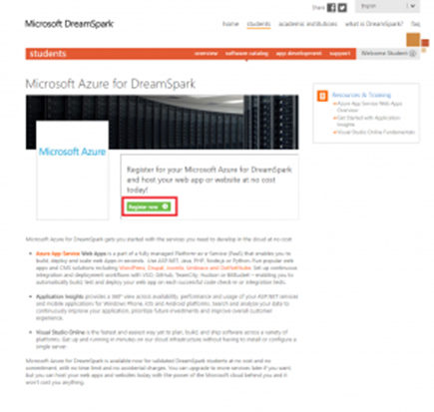](http://www.thinklikefink.com/wp-content/uploads/2015/03/DreamSpark01.png)

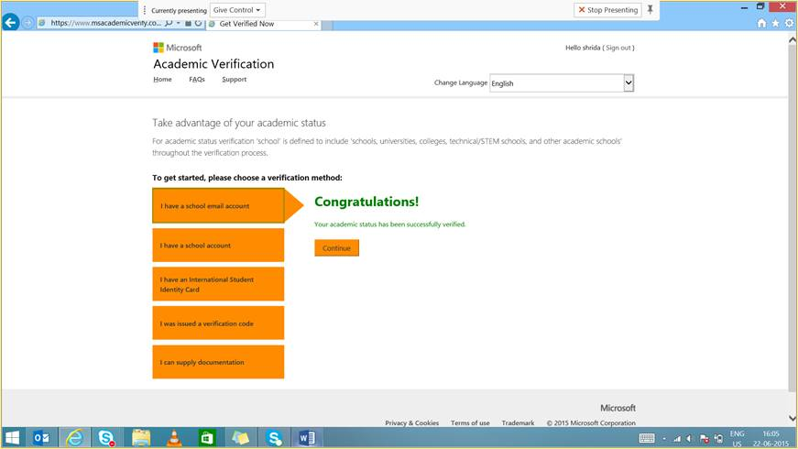

**Step 2: Sign in**

Yes, you may be asked a second time to sign in

Or

You may be redirected to homepage where in you click on Get started with Azure

[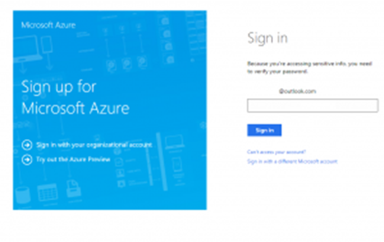](http://www.thinklikefink.com/wp-content/uploads/2015/03/DreamSpark02.png)

**Step 3: Register with Azure**

You will need to provide some basic information about yourself, including a phone number which can receive text messages or phone calls for verification.

This is mandatory as one can get account activated only post phone verification(call or text).

[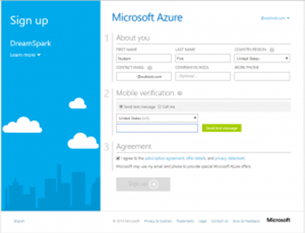](http://www.thinklikefink.com/wp-content/uploads/2015/03/DreamSpark03.png)

**Step 4: Wait for activation**

Once you compete the application form, you will be directed to a waiting page. This is a brief pause while your account is set up and activated. It should only take a 4-5 minutes.

[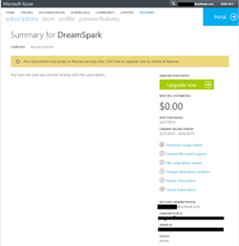](http://www.thinklikefink.com/wp-content/uploads/2015/03/DreamSpark04.png)

**Step 5: Visit the portal**

You will finally be redirected to this page.

This is the very last step, for signing up, and is actually your very first step towards building amazing things with Microsoft Azure. The portal is the gateway to all of the features available in Azure. It’s also your status page and cloud dashboard.

